HOSPITAL EMERGENCY ROOM DASHBOARD

PROJECT OVERVIEW
The Hospital Emergency Room Dashboard provides a comprehensive view of hospital emergency performance metrics across multiple dimensions — patient flow, satisfaction, admission patterns, demographics, and departmental efficiency.
It enables hospital administrators to monitor KPIs, identify bottlenecks, and optimize staff allocation, resulting in improved patient care and operational efficiency.

TECH STACK
- Tool Used: Microsoft Power BI
- Data Processing: Power Query
- Data Storage: Excel / CSV datasets
- Data Model: Star Schema
- Visualization Tools: Power BI Charts, Cards, Donut Charts, Heatmaps, and Slicers
- Scripting / ETL: Power Query M language
- Icons & Navigation: Power BI Buttons and Bookmarks

DATASETS (RECOMMENDED SOURCES)
Dataset Name | Description | Source Type
Patients.csv | Contains patient demographics, wait time, satisfaction score, and admission status | Hospital Database / Excel
Departments.csv | Department names and referral details | Hospital HR or Admin System
Admissions.csv | Admission and referral data | Hospital Record Management System
Date_Dimension.csv | Calendar table for time intelligence | Generated using Power Query

DATA PREPARATION & ETL
- Data Loading:
  - Import all datasets (Patients, Admissions, Departments, Date).
- Data Cleaning:
  - Handle missing values (e.g., “Declined to Identify” in race/gender fields).
  - Standardize date formats and categorical labels.
- Transformations:
  - Add calculated columns for Wait Time Category, Age Group, and Admission Status (%).
- Merging:
  - Merge datasets using Patient ID and Department ID as keys.
- Data Validation:
  - Verify counts, averages, and satisfaction scores to ensure consistency.

DATA MODEL (RECOMMENDED)
Star Schema Model
Fact Table:
- FactPatientVisits (Patient ID, Department ID, Date, Wait Time, Admission Status, Referral, Satisfaction Score)
Dimension Tables:
- DimPatient (Patient ID, Gender, Age, Race)
- DimDepartment (Department ID, Department Name)
- DimDate (Date, Month, Year, DayOfWeek)
Relationships:
- FactPatientVisits[Patient ID] → DimPatient[Patient ID]
- FactPatientVisits[Department ID] → DimDepartment[Department ID]
- FactPatientVisits[Date] → DimDate[Date]

KEY DAX MEASURES (KPIS)

Admission Hour = Hour('Hospital ER_Data'[Patient Admission Date])
Admission Status = IF('Hospital ER_Data'[Patient Admission Flag] = TRUE, "Admitted", "Not Admitted")
Age Group =
SWITCH(
TRUE(),
'Hospital ER_Data'[Patient Age] >= 100, "100+",
'Hospital ER_Data'[Patient Age] >= 90, "90-99",
'Hospital ER_Data'[Patient Age] >= 80, "80-89",
'Hospital ER_Data'[Patient Age] >= 70, "70-79",
'Hospital ER_Data'[Patient Age] >= 60, "60-69",
'Hospital ER_Data'[Patient Age] >= 50, "50-59",
'Hospital ER_Data'[Patient Age] >= 40, "40-49",
'Hospital ER_Data'[Patient Age] >= 30, "30-39",
'Hospital ER_Data'[Patient Age] >= 20, "20-29",
'Hospital ER_Data'[Patient Age] >= 10, "10-19",
"0-9")
Average wait time = FORMAT(AVERAGE('Hospital ER_Data'[Patient Waittime]), "0.0") & " " & "Min"
No of Patient Referred = CALCULATE(COUNTROWS('Hospital ER_Data'), 'Hospital ER_Data'[Department Referral] <> "None")
No of patients = DISTINCTCOUNT('Hospital ER_Data'[Patient Id])
Patient Admin Date = DATE(YEAR('Hospital ER_Data'[Patient Admission Date]), MONTH('Hospital ER_Data'[Patient Admission Date]), DAY('Hospital ER_Data'[Patient Admission Date]))
Satisfaction Score = AVERAGE('Hospital ER_Data'[Patient Satisfaction Score])
Waittime Interval =
SWITCH(
TRUE(),
'Hospital ER_Data'[Admission Hour] < 2, "00-02",
'Hospital ER_Data'[Admission Hour] < 4, "03-04",
'Hospital ER_Data'[Admission Hour] < 6, "05-06",
'Hospital ER_Data'[Admission Hour] < 8, "07-08",
'Hospital ER_Data'[Admission Hour] < 10, "09-10",
'Hospital ER_Data'[Admission Hour] < 12, "11-12",
'Hospital ER_Data'[Admission Hour] < 14, "13-14",
'Hospital ER_Data'[Admission Hour] < 16, "15-16",
'Hospital ER_Data'[Admission Hour] < 18, "17-18",
'Hospital ER_Data'[Admission Hour] < 20, "19-20",
'Hospital ER_Data'[Admission Hour] < 22, "21-22",
'Hospital ER_Data'[Admission Hour] < 24, "23-24",
"Above 24"
)
Waittime ststus = IF('Hospital ER_Data'[Patient Waittime]<=30, "Within Target", "Target Missed")
Table = CALENDAR(MIN('Hospital ER_Data'[Patient Admission Date]),MAX('Hospital ER_Data'[Patient Admission Date]))
Day Name = FORMAT('Table'[Date], "DDD")
MONTH & YEAR = 'Table'[Date] .[Month] & " " & 'Table'[Year]
Month Name = FORMAT('Table'[Date], "mmm")
MONTH NUMBER = MONTH('Table'[Date])
Week Day = WEEKDAY('Table'[Date], 2)
Year = YEAR('Table'[Date])

DASHBOARD PAGES (DETAILED)
Monthly View
- Displays month-specific metrics (e.g., February 2024).
- KPIs:
  - Total Patients
  - Average Waiting Time
  - Satisfaction Score
  - Number of Patients Referred
- Visuals: Line Charts, Donut Chart (Patients seen within 30 mins), Age Group & Gender Distribution, Day-Hour Heatmap.
- 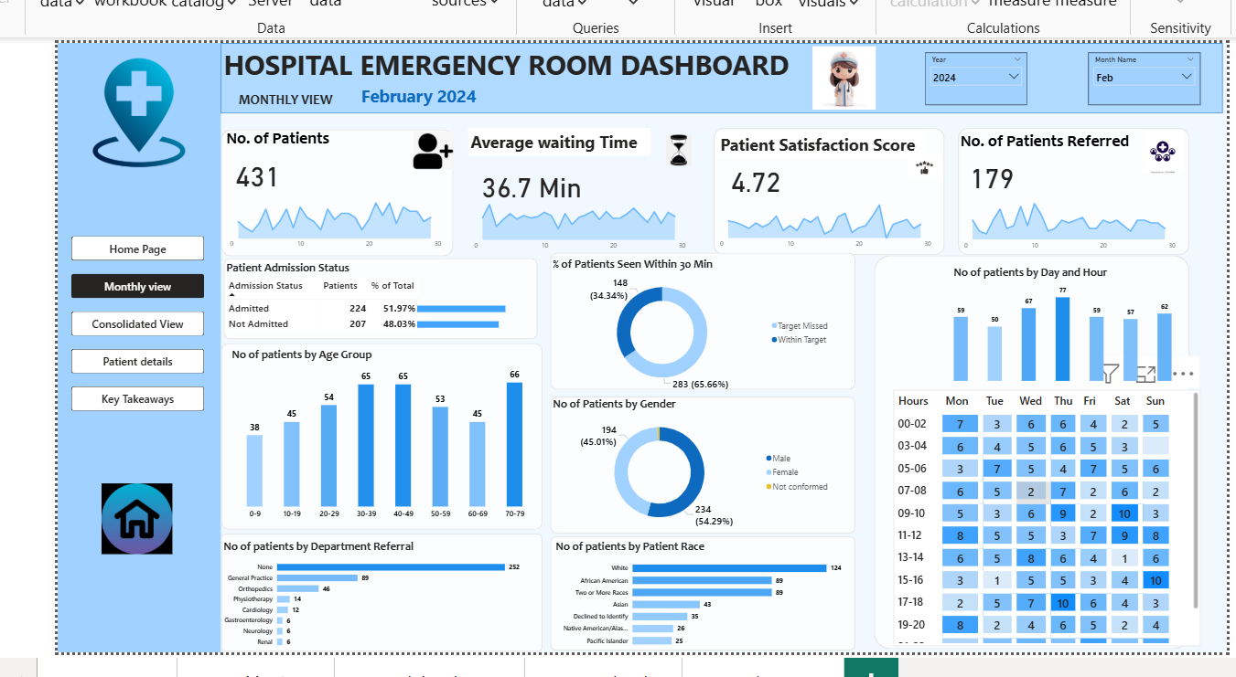

Consolidated View
- Displays overall performance (April 2023 – October 2024).
- KPIs:
  - Total Patients
  - Average Waiting Time
  - Satisfaction Score
  - Referred Patients
- Visuals: Monthly trend charts, Age Group comparison, Gender & Race breakdowns, Hourly activity heatmap.

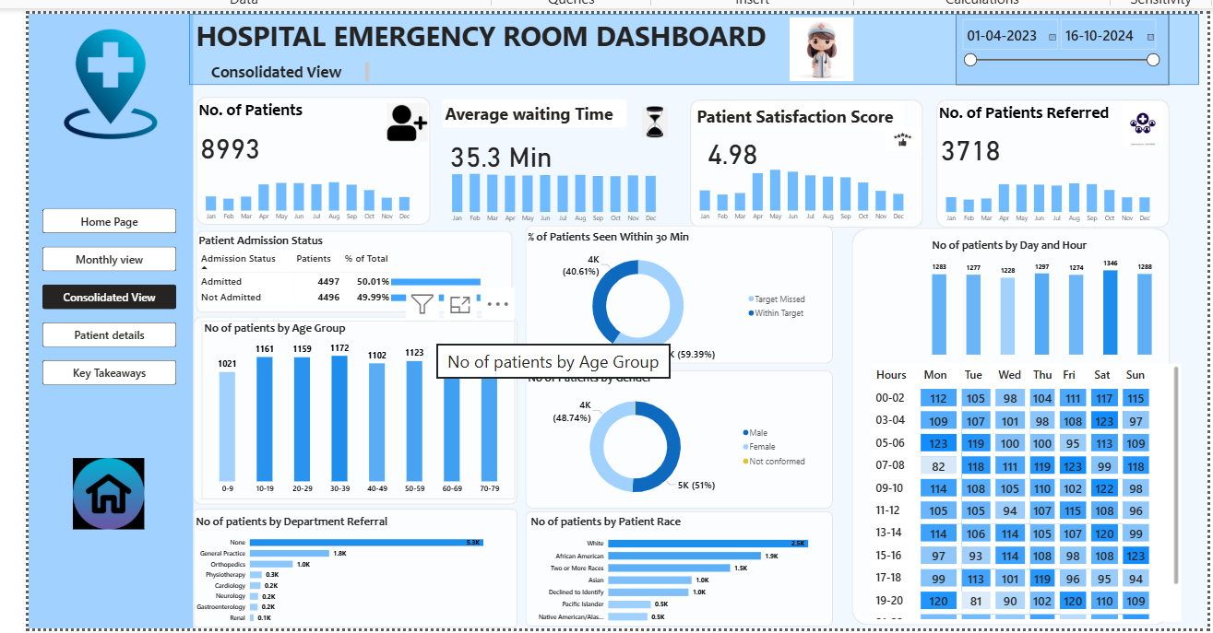

Patient Details
- Interactive table showing:
  - Patient ID, Name, Gender, Age, Race, Wait Time, Admission Status, Department Referral.
- Filterable by date range, gender, and admission type.

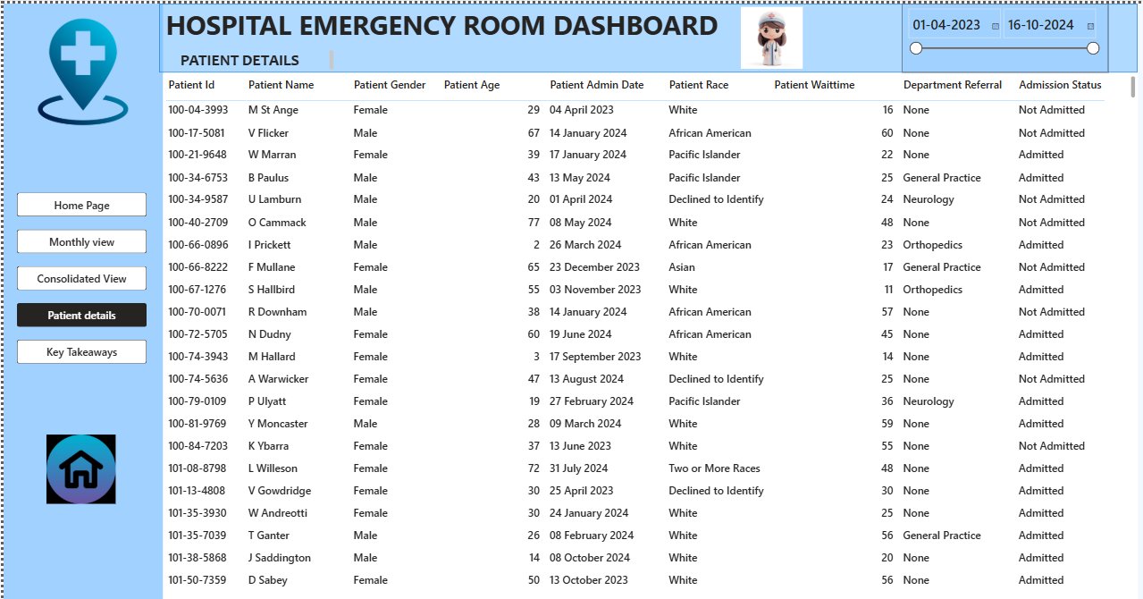

Key Takeaways
- Descriptive summary generated from dashboard data:
  - Wait Time & Satisfaction insights
  - Departmental Referral patterns
  - Peak busy days/hours
  - Demographic analysis
  - Admission vs Non-admission statistics
- Useful for presentations or executive summaries.

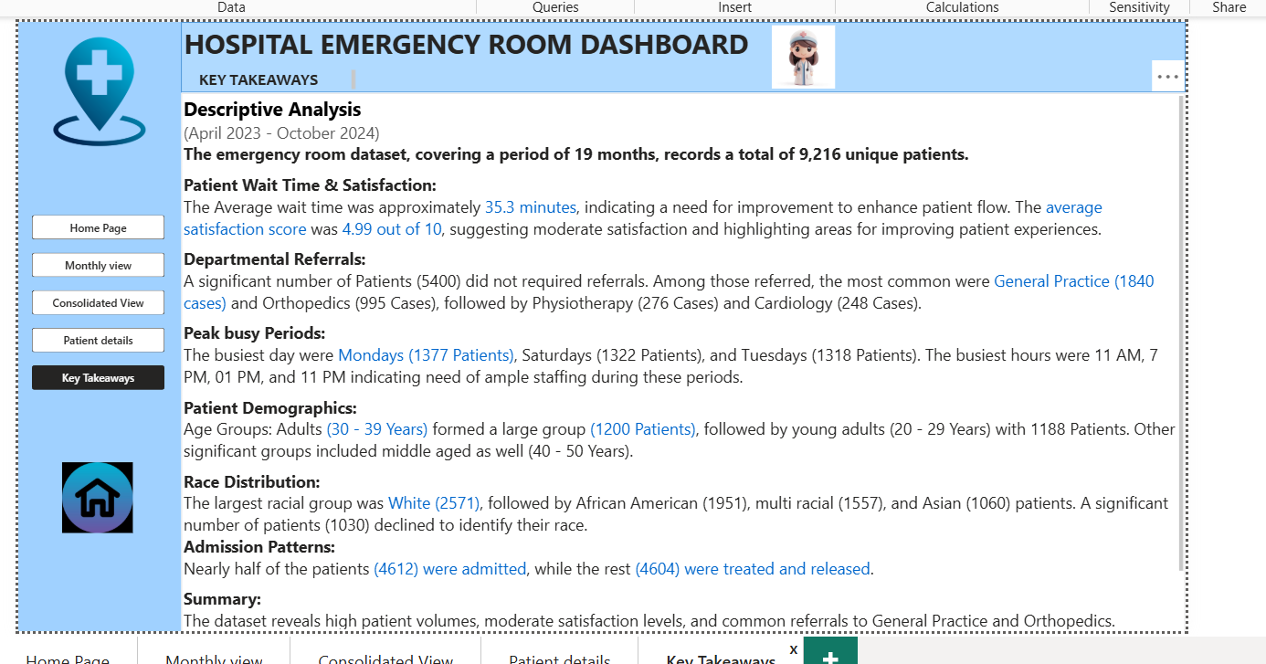

KPI’s (Key Performance Indicators)
KPI Name | Description
No. of Patients | Total unique patients visiting ER
Average Waiting Time | Mean wait time before treatment
Patient Satisfaction Score | Average score (1–5 scale)
Patients Referred | Count of patients referred to departments
% Patients Seen Within 30 Min | Efficiency metric for prompt service
Admission Rate (%) | Percentage of admitted vs non-admitted
Peak Hours & Days | Identifies busiest operational periods

INTERACTIVE UI ELEMENTS
- Navigation Buttons: Home, Monthly View, Consolidated View, Patient Details, Key Takeaways.
- Date Range Slicer: To filter data by custom time periods.
- Dropdown Filters: Year and Month selection.
- Interactive Charts: Click-based filtering on age, gender, and department visuals.
- Hover Tooltips: Show detailed data on hover for trend and donut charts.

SUMMARY
The Hospital Emergency Room Dashboard offers an end-to-end analytical solution for monitoring emergency department efficiency.
It provides actionable insights into:
- Patient waiting times and satisfaction trends
- Departmental workload and referrals
- Admission patterns and demographic insights
- Peak time analytics for better staffing decisions
This interactive Power BI dashboard empowers hospital management to make data-driven operational decisions that enhance patient care and optimize hospital resources.

